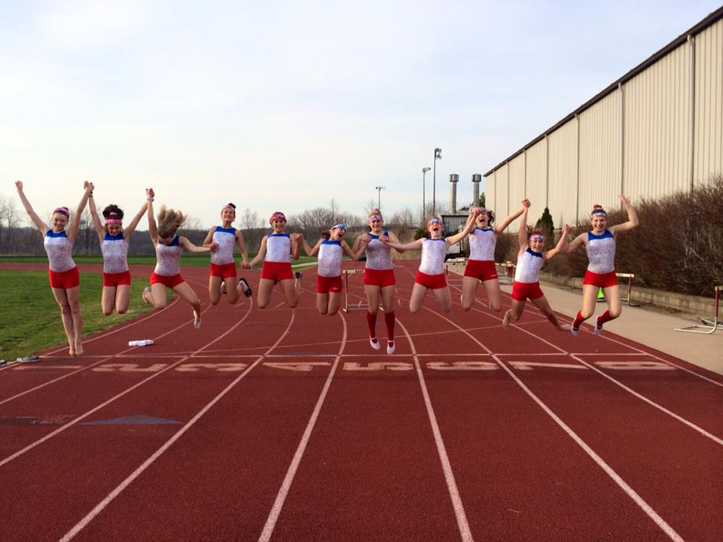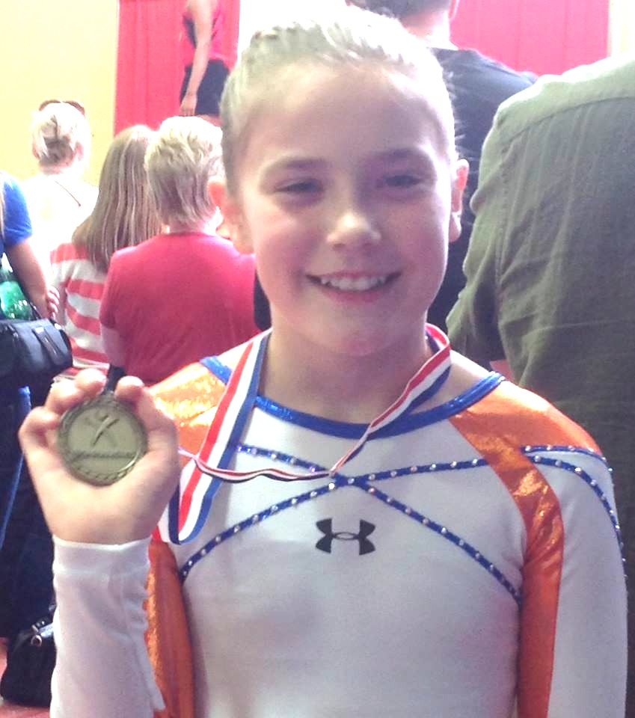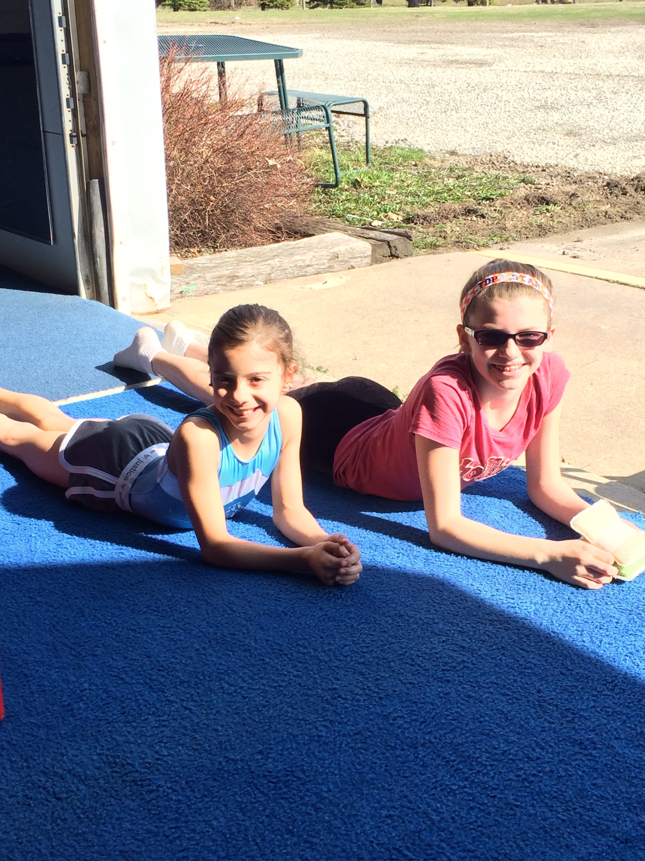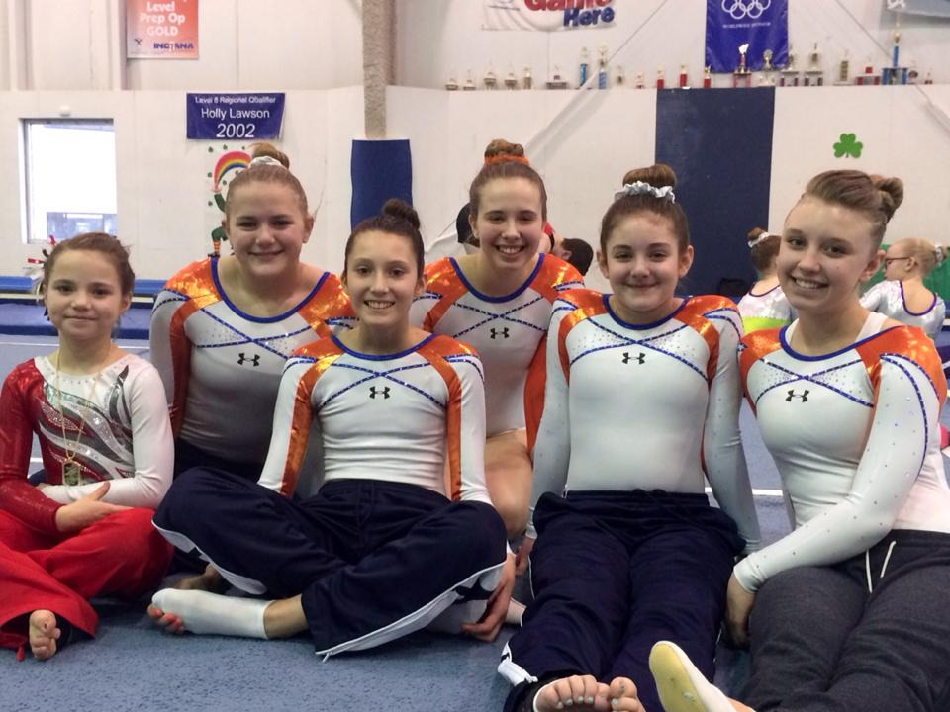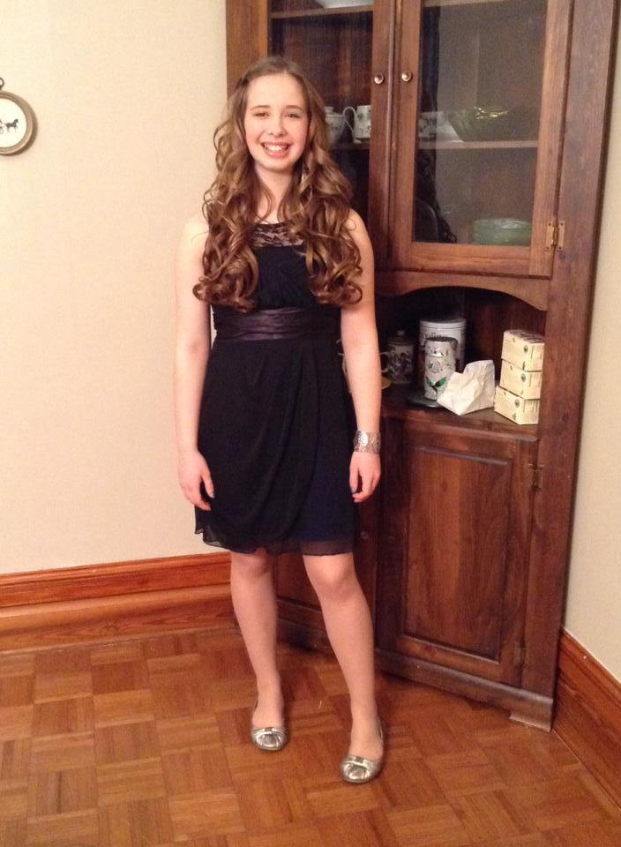

Top Star takes pride in having an educated staff. Not only does every one of our coaches have a background in the sports of tumbling and/or cheerleading, they are also offered multiple educational courses through USA Gymnastics University, a national institution focused on redefining gymnastics education. We want our parents and athletes to feel confident in our coaches’ abilities to teach them safely and properly. Here is a list of our coaching staff credentials and completed courses.

-USTA Safety Certified Missy Weder, Erin Turner, Cassie Butcher, Morgan Workman, Kait Hunt, Kira McCalip, Delaney Walsh, Raea Weder

-USAG Safety & Risk Management Certified Missy Weder, Erin Turner, Cassie Butcher

-Fundamentals of Gymnastics Certification Missy Weder, Erin Turner, Cassie Butcher

-USAG Trampoline & Tumbling 2014 Update Missy Weder, Erin Turner, Cassie Butcher

-Trampoline & Tumbling Developmental Coaches Course Missy Weder, Erin Turner, Cassie Butcher

-Trampoline & Tumbling Hands On Coaches Training Missy Weder, Erin Turner, Cassie Butcher

-CPR and AED Certified Erin Turner, Cassie Butcher

Congratulations to Top Star’s four USAG State Champions of 2014! The USAG State competition took place in East Peoria on Saturday April 12th. After the competition the Midwest Challenge was held for athletes level 5 and up. The Midwest Challenge is a fun meet where the passes are made up and the points don’t matter!! The goofier the salutes and passes, the better! Our athletes had a blast and so did the coaches! We can’t wait until next year!

## Kendra Snelling

## State Champion

## Floor

## Bri Struck State Champion Double mini & Trampoline

## Morgan Estes State Champion Double mini

## Payton Turk State Champion Trampoline

May 2014

Top Star Newsletter

- Makenna Cravens: 2nd on double mini & trampoline, 3rd on floor

- Betty Kennerly: 2nd on double mini & trampoline, 3rd on floor

- Payton Turk: 1st on trampoline, 3rd on double mini

- Bri Struck: 1st on trampoline & double mini

- Corinna Robinson: 5th on double mini

- Abby Dunham: 2nd on double mini, 5th on trampoline

- Hannah Hong: 2nd on trampoline, 5th on

double mini

- Makenna Fiscus: 2nd on trampoline, 3rd on double mini

- Morgan Estes: 1st on double mini, 4th on trampoline

- Melissa Singleton: 5th on trampoline

- Riley Kofoed: 3rd on trampoline

- Paige Hoerner: 2nd on trampoline

- Lizzie Scott: 2nd on trampoline

**Top Star T&T – April 26th & 27th – Decatur, IL** (USTA state! Look who got 5th place or higher!)

- Delaney Walsh: 1st on trampoline, 4th on double mini

- Payton Turk: 3rd on double mini, 5th on trampoline

- Spencer Lahners: 3rd on trampoline, 4th on double mini

**Top Star T&T – April 5th & 6th – Chatham, IL** (Look who got 5th place or higher!)

- Payton Turk: 3rd on double mini

- Connelly Lahners: 2nd on double mini & 4th on trampoline

- Spencer Lahners: 2nd on trampoline & double mini

- Sierra Taylor: 2nd on floor

**Top Star Flyers – April 5th – DeQuoin, IL**

- Junior Level 1’s:

- Junior Level 2’s:

**Top Star T&T – April 12th – East Peoria, IL** (USAG state! Look who got 5th place or higher!)

- Grace Skube: 2nd on floor, 4th on trampoline, 5th on double mini

- Kendra Snelling: 1st on floor

- Taylor Hannagan: 5th on floor

- Sierra Taylor: 3rd on floor, 5th on double mini

- Meredith Hogue: 4th on floor

- Beth Born: 3rd on floor, 4th on trampoline, 5th on double mini

- Maddie Sikora: 2nd on trampoline, 3rd on double mini, 5th on floor

- Clementine Craft: 2nd on floor

April Competition Results

Upcoming Competitions!

May 3rd – Cheer competition in Benton, Illinois

May 17th & 18th – USAG T&T Regional competition in Peoria, Illinois

May 18th – Cheer State competition in Effingham, Illinois

Top Star would like to recognize Meredith Hogue for scoring PERFECT 10’s across the board on double mini at the USAG State competition!

10.0

10.0

10.0

#### Meet the Coach Samantha Saunders – T&T coach

Sammi was born and raised in Waterford, Connecticut. She started cheering when she was just 5 years old! Sammi cheered for an All Star, senior level 5 squad called East Celebrity Elite. In 2007 the team got their first bid to worlds and placed 9th out of 80 teams from around the globe! The squad made it to worlds 3 times before Sammi retired from cheerleading. She took 4 years of hip-hop at her cheer gym in Connecticut and was involved in gymnastics for 7 years! Tumbling has always been her favorite event and she has been coaching on and off for over 10 years! Sammi has been with Top Star for 2 years now and is well loved by everyone in the gym! She is very laid back and has great patience with her athletes!

In addition to coaching, Sammi serves and bartends at Jupiter’s here in Champaign. She is going back to school to pursue her interest in the medical field.

If you see any of these kids around the gym, be sure to wish them a happy birthday!

May 14th – Dustin McCleary, Payton Quinley, & Coach Raea

May 17th – Zorah Fullop

May 21st – Karissa Gobble

May 22nd – Kirsten Schaefer

May 27th – Nyah Biegler

May 31st – Sydni Harvey

May 6th – Alayna Evans

May 7th – Corinna Robinson

May 1st – Brock & Brohden Evans

There is an online resource provided by USA Gymnastics made just for parents! Got questions? You can get them answered by USA Gymnastics staff and other parents just like you! This website offers loads of articles and testimonials about what makes tumbling so great! Every month a free webinar is offered to parents focusing on matters such as how to help your children gain more confidence and how to keep your active, athletic family organized. On top of all of that, there are videos created by experts available for parents and gymnasts. It is a wonderful resource that we encourage all of our parents to check out!

www.usagymclub.com

Parents: Did You Know?!

# May Birthdays!

Macintosh HD:Users:erinturner:Pictures:Newsletter:taglinelogo.ps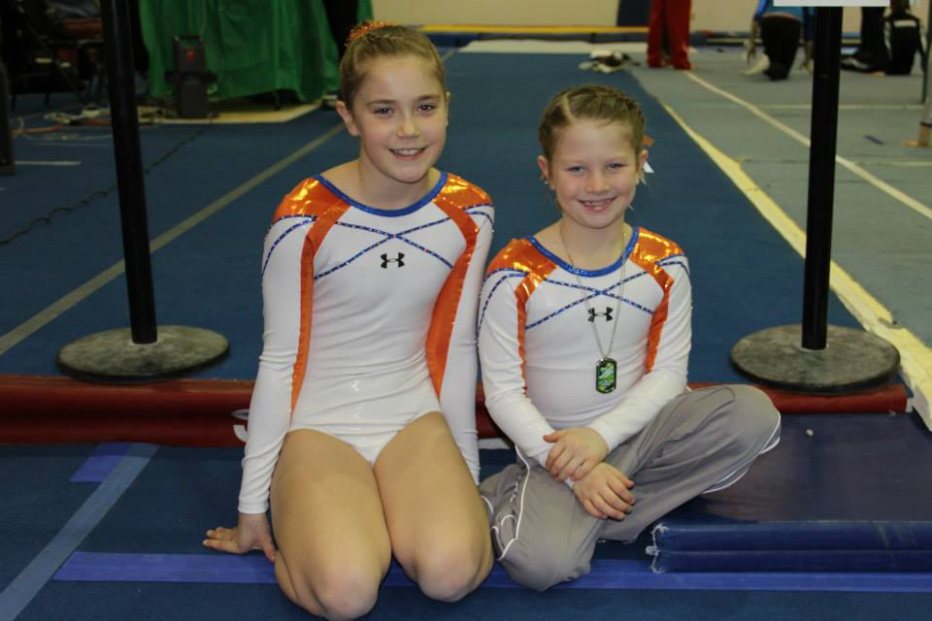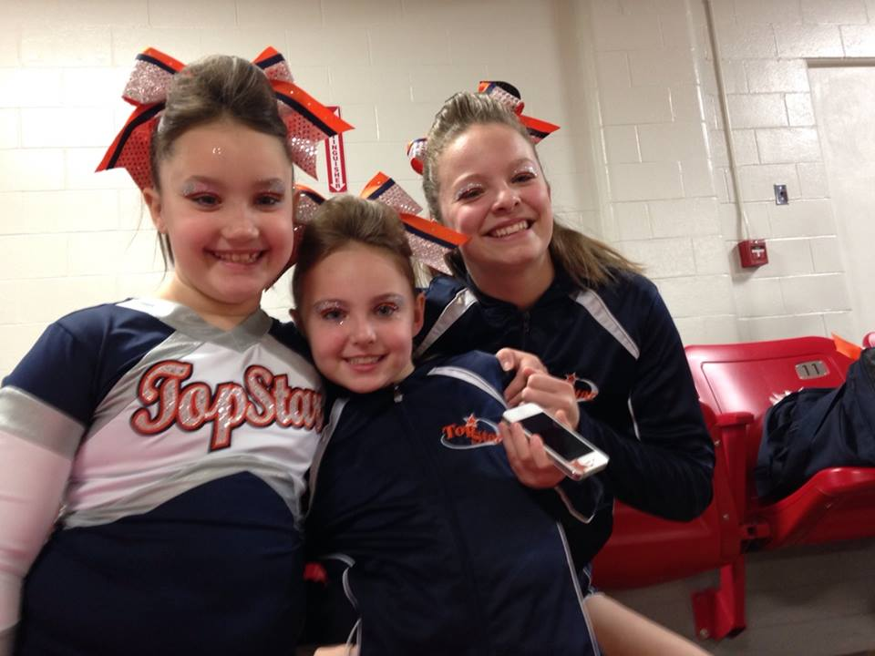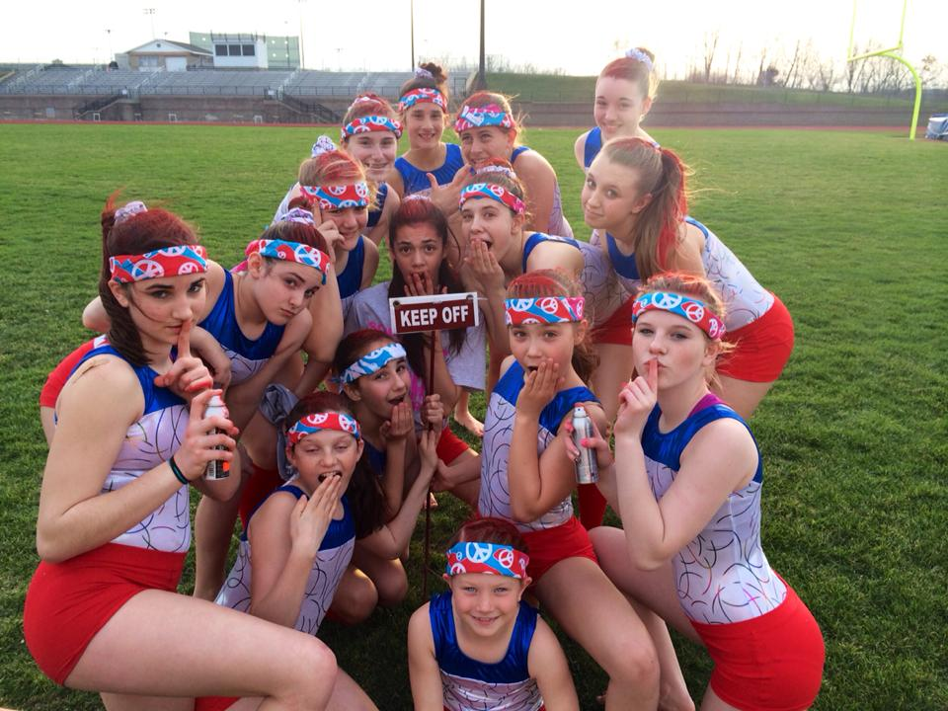

Due to the cancellation of the April pizza party, we have decided to make May a pizza party-Lock-In combination! The pizza party will run from 6:00 to 9:00 on Friday, May 9th and is $15 per child. The Lock-In is for children ages 7 and up only! If your child will be attending the pizza party AND the Lock-In, the price is $20 per child. Pick up is at 8:00am Saturday morning. Friends are welcome to the pizza party! Any friends who wish to attend will be asked to pay an annual $25 registration fee (for insurance purposes) along with the standard $15 pizza party rate. A Top Star registration form and event waiver will need to be filled out by a legal guardian as well. That friend may then attend any future Top Star pizza parties for the standard $15. There is a sign-up sheet on the table by the office. Please be sure to mark the “Lock-In” box if you will be staying for that. Please write down any friend’s names as well. We look forward to seeing you and all your friends!

**What to bring to the Lock-In:** pajamas, a sleeping bag & pillow, toothbrush & toothpaste!

#### May Pizza Party

#### & Lock-In!

#### We are so proud of our athletes, parents and coaches. Thank you for your dedication, loyalty and support in helping us create a successful and confident family atmosphere.

**Top Star Training Center**

1708 W. Hensley Rd

Champaign Illinois

217-378-5058

topstargym.net

topstargym@hotmail.com