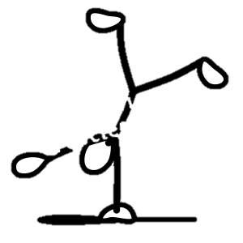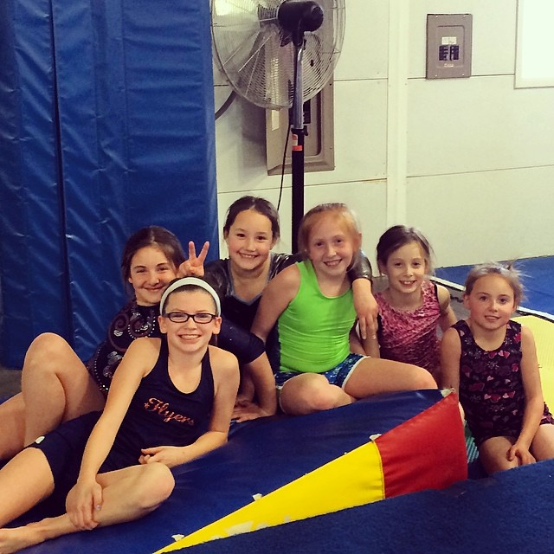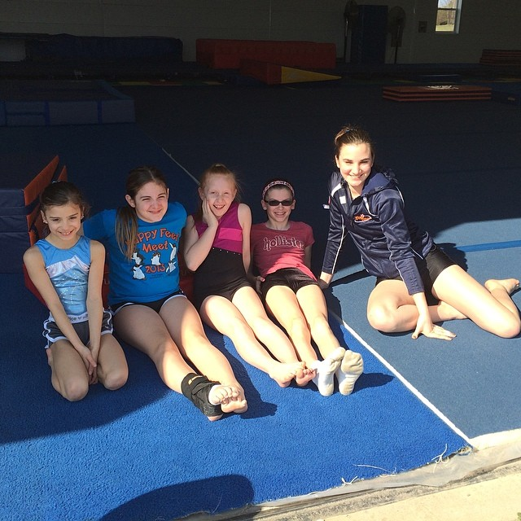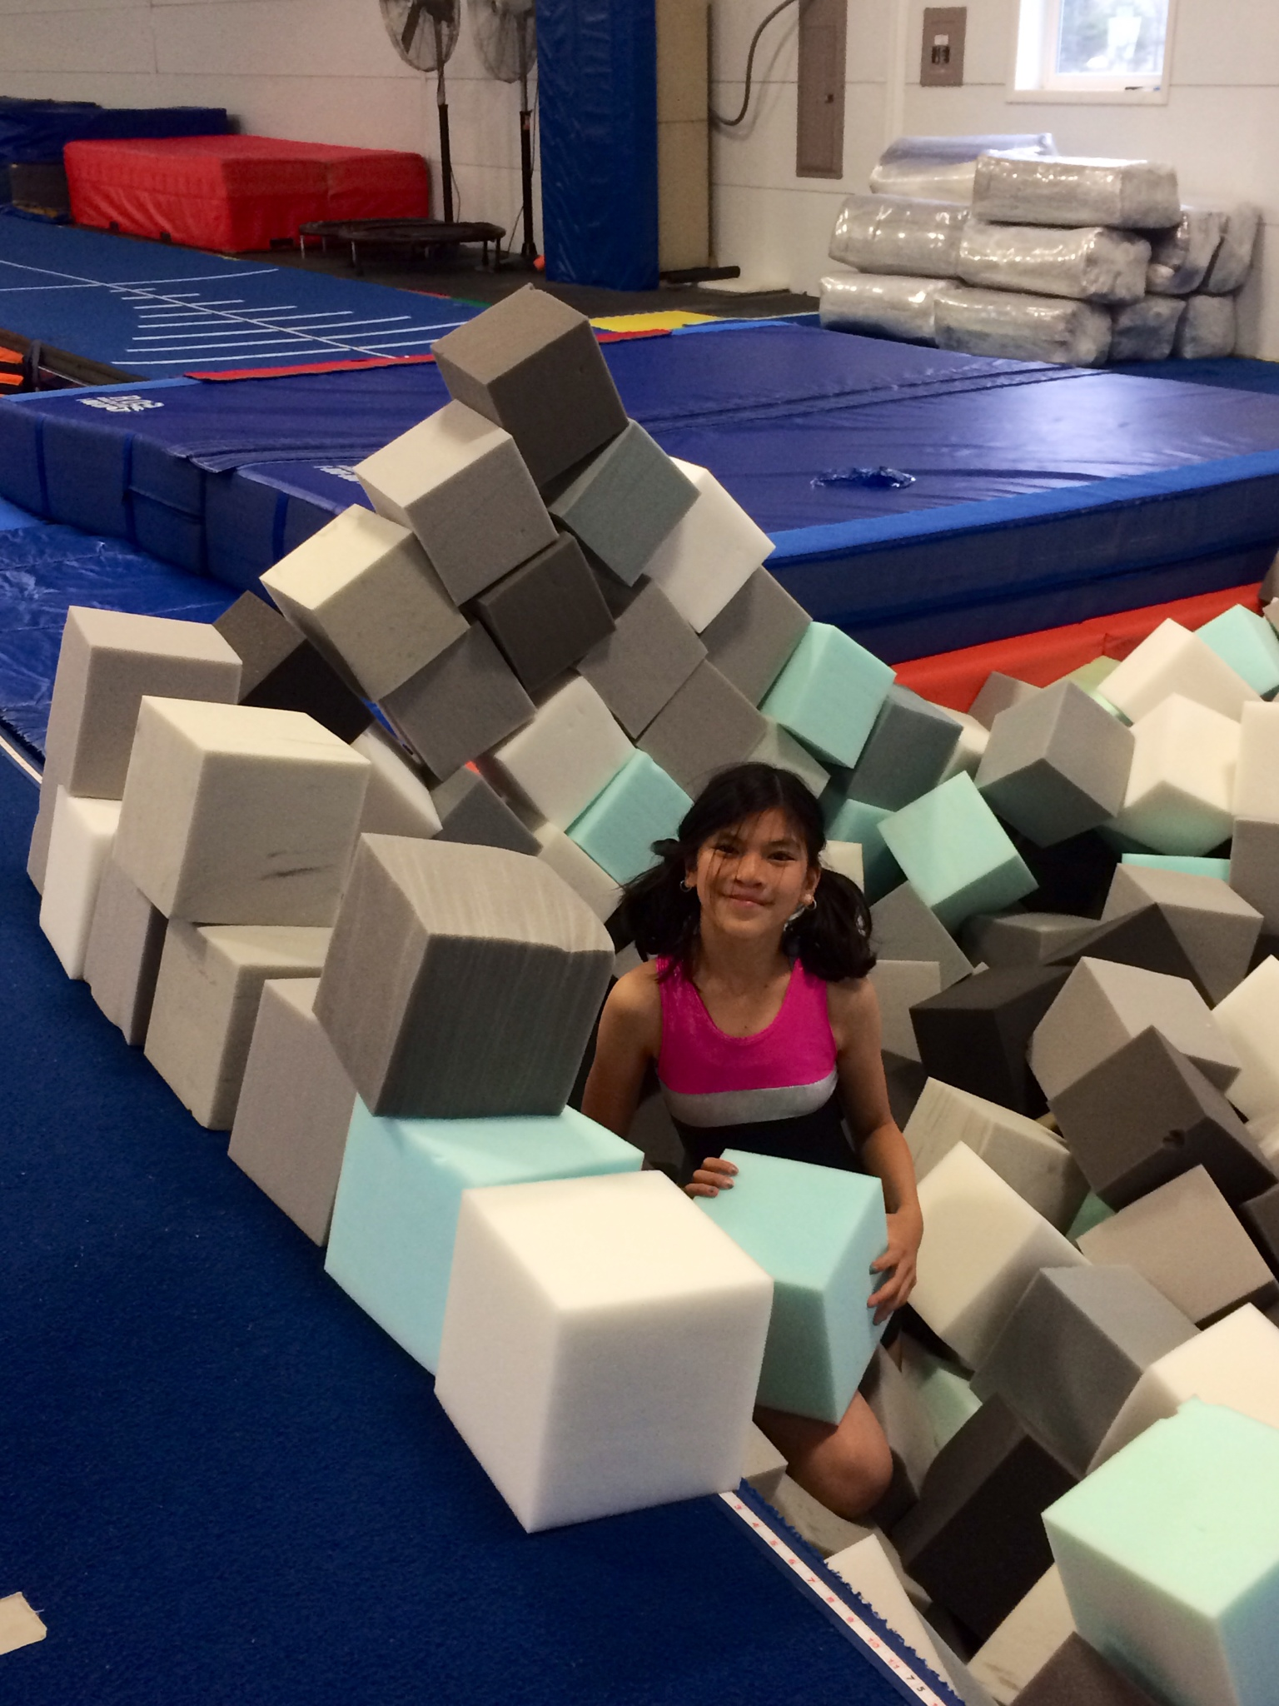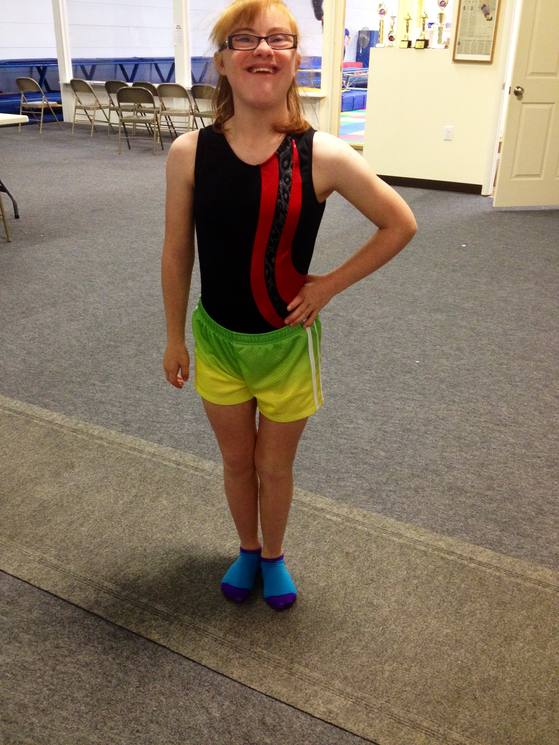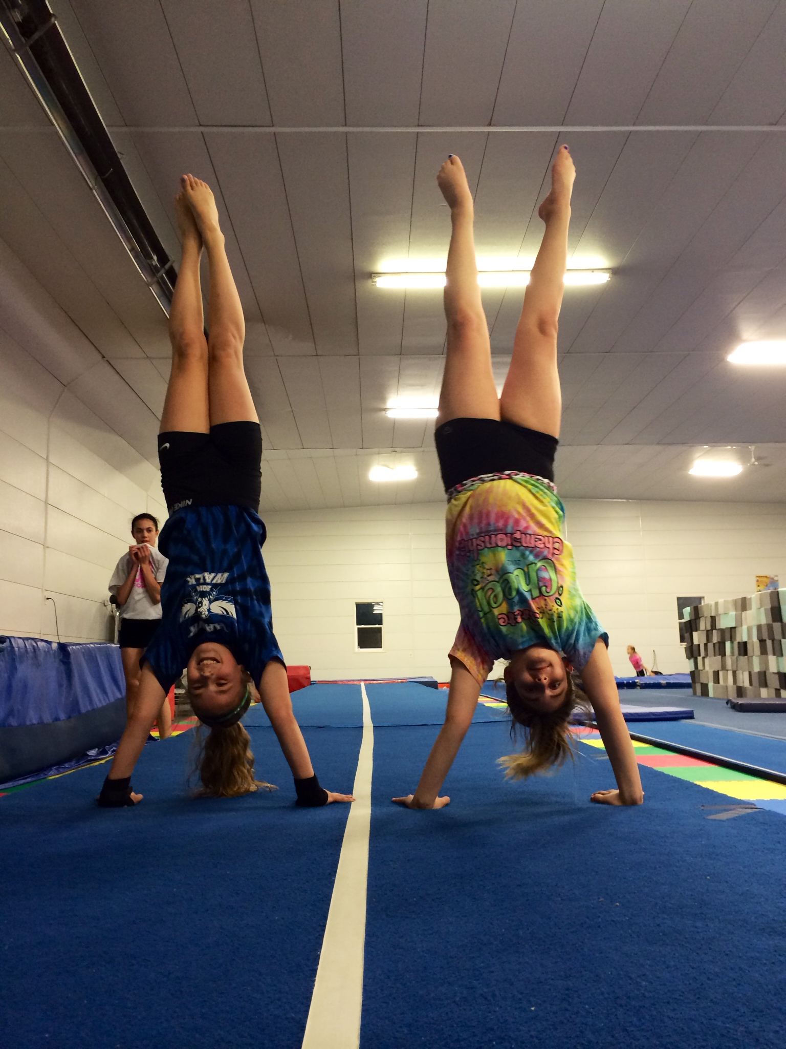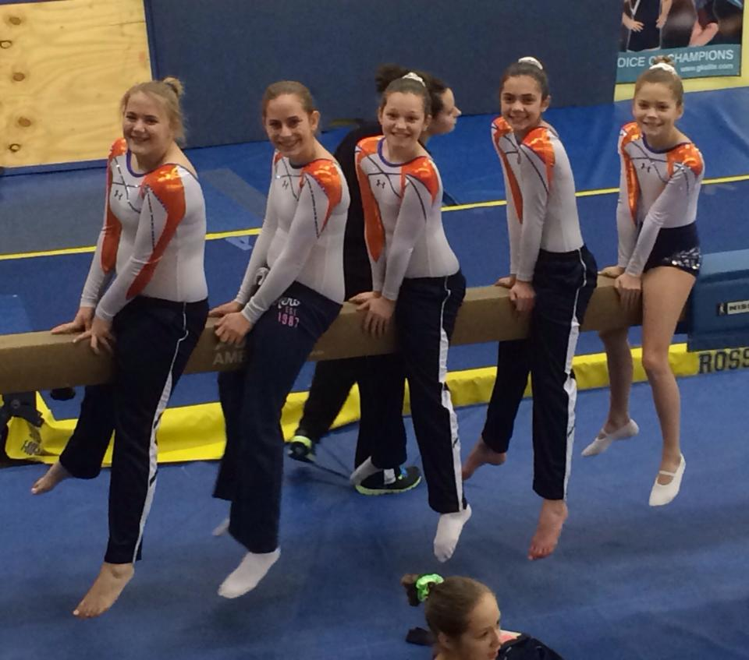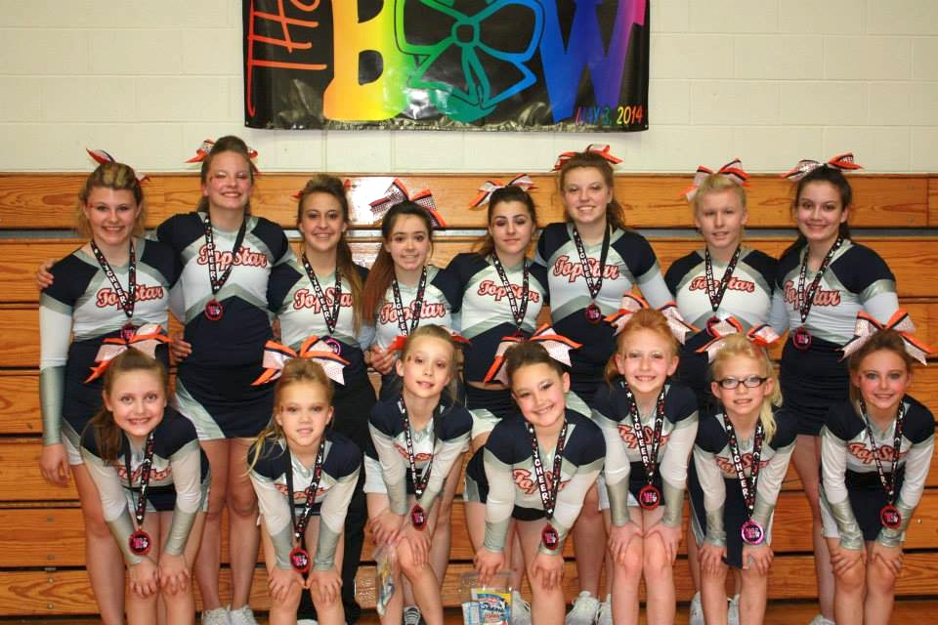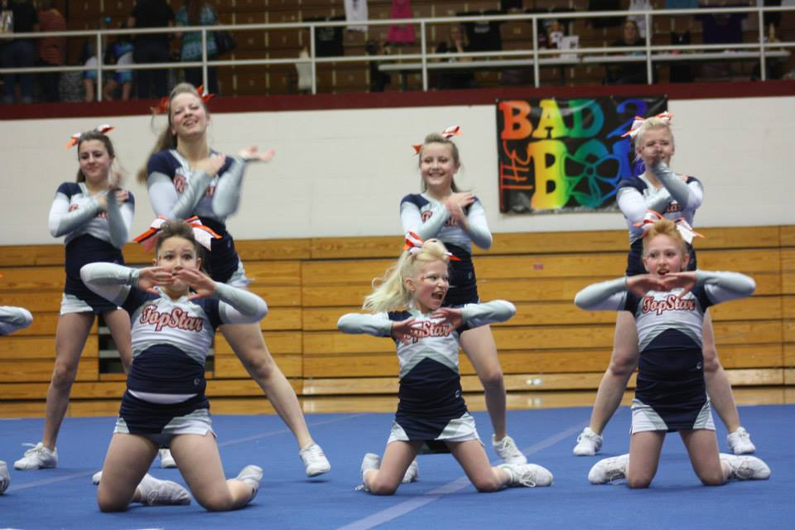

June 3rd: Aryanna Jeffries

June 4th: Julia Mulvaney

June 6th: Avery Gordon

June 8th: Camryn Conner

June 10th: Izzy Warner

June 17th: Brenlee Dalton

June 21st: Hanna Eastin

June 22nd: Trinity Tapia

June 27th: Grace Stoerger

If you see any of these kids around the gym, be sure to wish them a happy birthday!

July 28th

through

August 14th

July 7th

through

July 24th

June 9th

through

June 26th

# Don’t forget!

Summer sessions are only 3 weeks long! Because of this, fees will be different from the standard monthly pricing that everyone is used to! You will still pay by the hour and the new price list is up on the white board by the office. Please consult the board or ask a member of our staff to assist you when paying per session. Also notice that the gym will be closed for a week between each session. We will offer open gyms and other events while we are closed!

Top Star Newsletter

### June Birthdays!

#### Save the Date!

##### Session 1

##### Session 3

##### Session 2

June 2014

###### We will be hosting another pizza party on Friday, June 27th! The party will run from 6:00 to 9:00 and will be $15 per child. Friends are welcome! Any friends who wish to attend will only need to pay the standard $15 pizza party rate and an event waiver will need to be filled out by a legal guardian. There is a sign-up sheet on the table by the office. Please write down any friend’s names as well. We look forward to seeing you and all your friends!

Anyone is welcome for only $15!

# June Pizza Party!

Morgan started trampoline and tumbling classes when she was three years old! She competed at an advanced level for about 6 years! Her favorite event has always been double mini and she thrived in Jump Start, a strength and flexibility program developed by USAG. In high school, Morgan played volleyball and ran track. She graduated from Monticello High School this past May and will be attending Parkland College in the fall. She is still undecided on her career path but is interested in the health field! Morgan is extremely energetic and her positive attitude is contagious! She is a natural with kids, which makes her a very valuable coach for Top Star! She is well looked upon by her athletes as well as the other coaches.

###### Morgan Workman – T&T Coach

# Meet the Coach

June Competitions:

USTA Nationals

June 16th – 21st

Louisville, Kentucky

# May Competition Results

- Beth Born: 3rd on trampoline, 6th on double mini

- Paige Hoerner: 5th on trampoline

- Taylor Hannagan: 7th on trampoline, 9th on double mini

- Delaney Walsh: 1st on double mini, 3rd on trampoline, 1st in synchronized trampoline with partner, Kelly Keitel

###### Top Star Flyers – May 18th – Effingham, IL

###### (State Competition!)

- Junior Level 1’s: 2nd place

- Junior Level 2’s: 3rd place

###### Top Star Flyers – May 3rd – Benton, IL

- Junior Level 1’s: 3rd place

- Junior Level 2’s: 2nd place

###### Top Star T&T – May 17th & 18th – Peoria, IL (USAG Regionals! Look who got 10th place or higher!)

- Hannah Hong: 8th on trampoline

- Riley Kofoed: 9th on double mini

- Trinity Tapia: 2nd on floor

- Abby Dunham: 6th on double mini, 8th on trampoline

- Corinna Robinson: 9th on trampoline, 10th on double mini

# Congratulations Top Star Flyers for earning 2nd and 3rd at the State Competition!

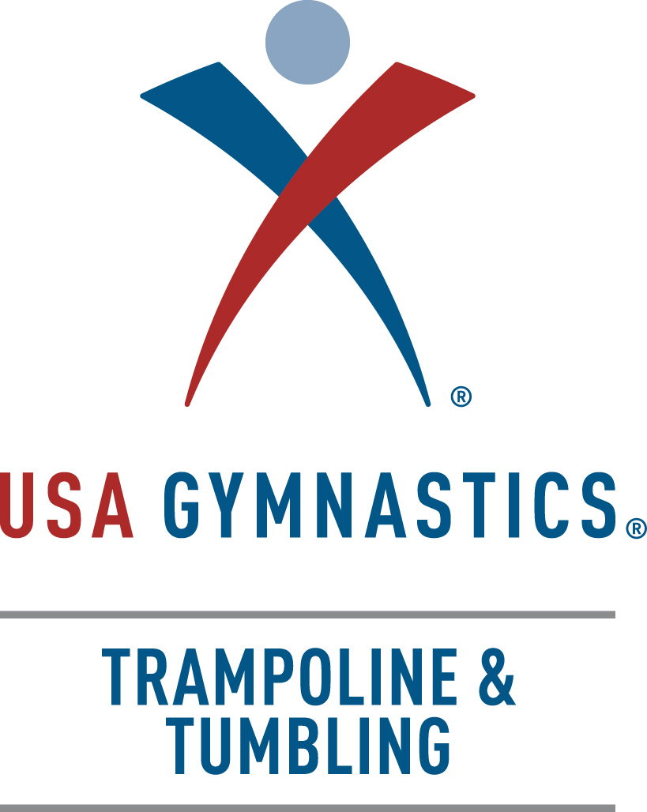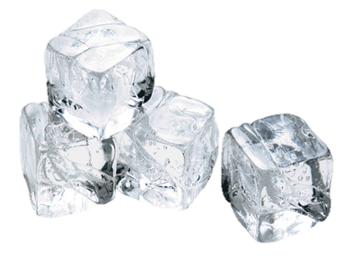

**Top Star Training Center**

1708 W. Hensley Rd

Champaign Illinois

217-378-5058

topstargym.net

topstargym@hotmail.com

#### We are so proud of our athletes, parents and coaches. Thank you for your dedication, loyalty, and support in helping us create a successful and confident family atmosphere.

* Jason Burnett (Canada) holds the world record for the highest trampoline difficulty ever preformed in competition at an 18.8. He is also noted for completing, in training, the worlds most difficult trampoline routine with a mind-blowing 20.6 difficulty! (For comparison, the highest difficulty you might see those crazy boys throwing at a local competition is around a 14.5!)

Cool Facts!

* George Nissen invented the trampoline in 1934.
* Trampoline didn’t become an Olympic event until the 2000 Olympics in Sydney, Australia. Double mini and Tumbling are still awaiting their debut!