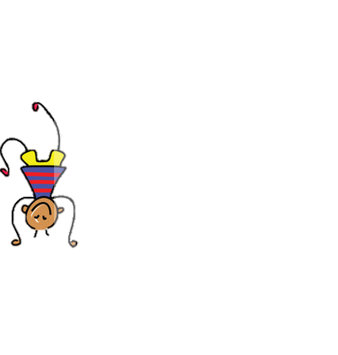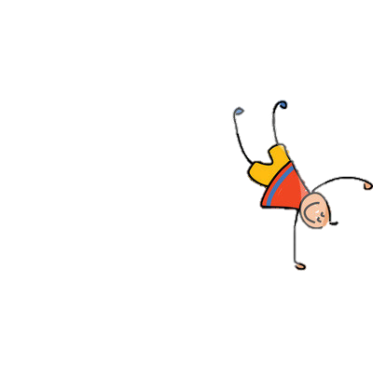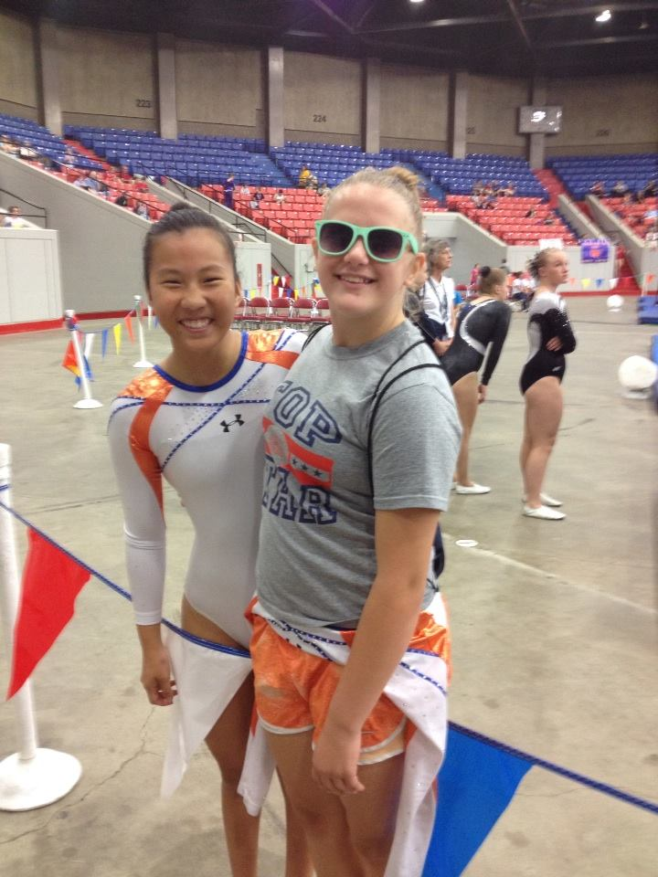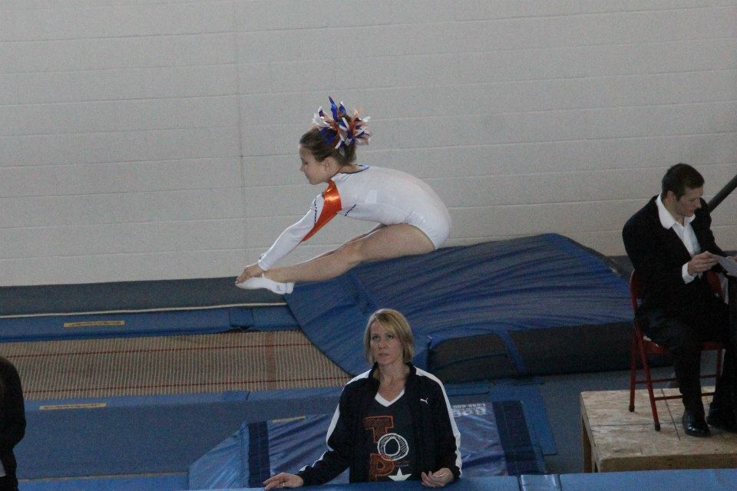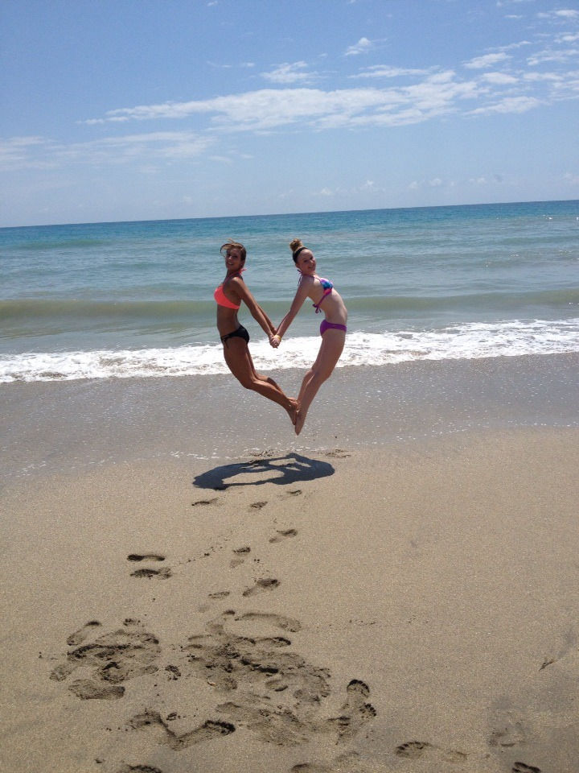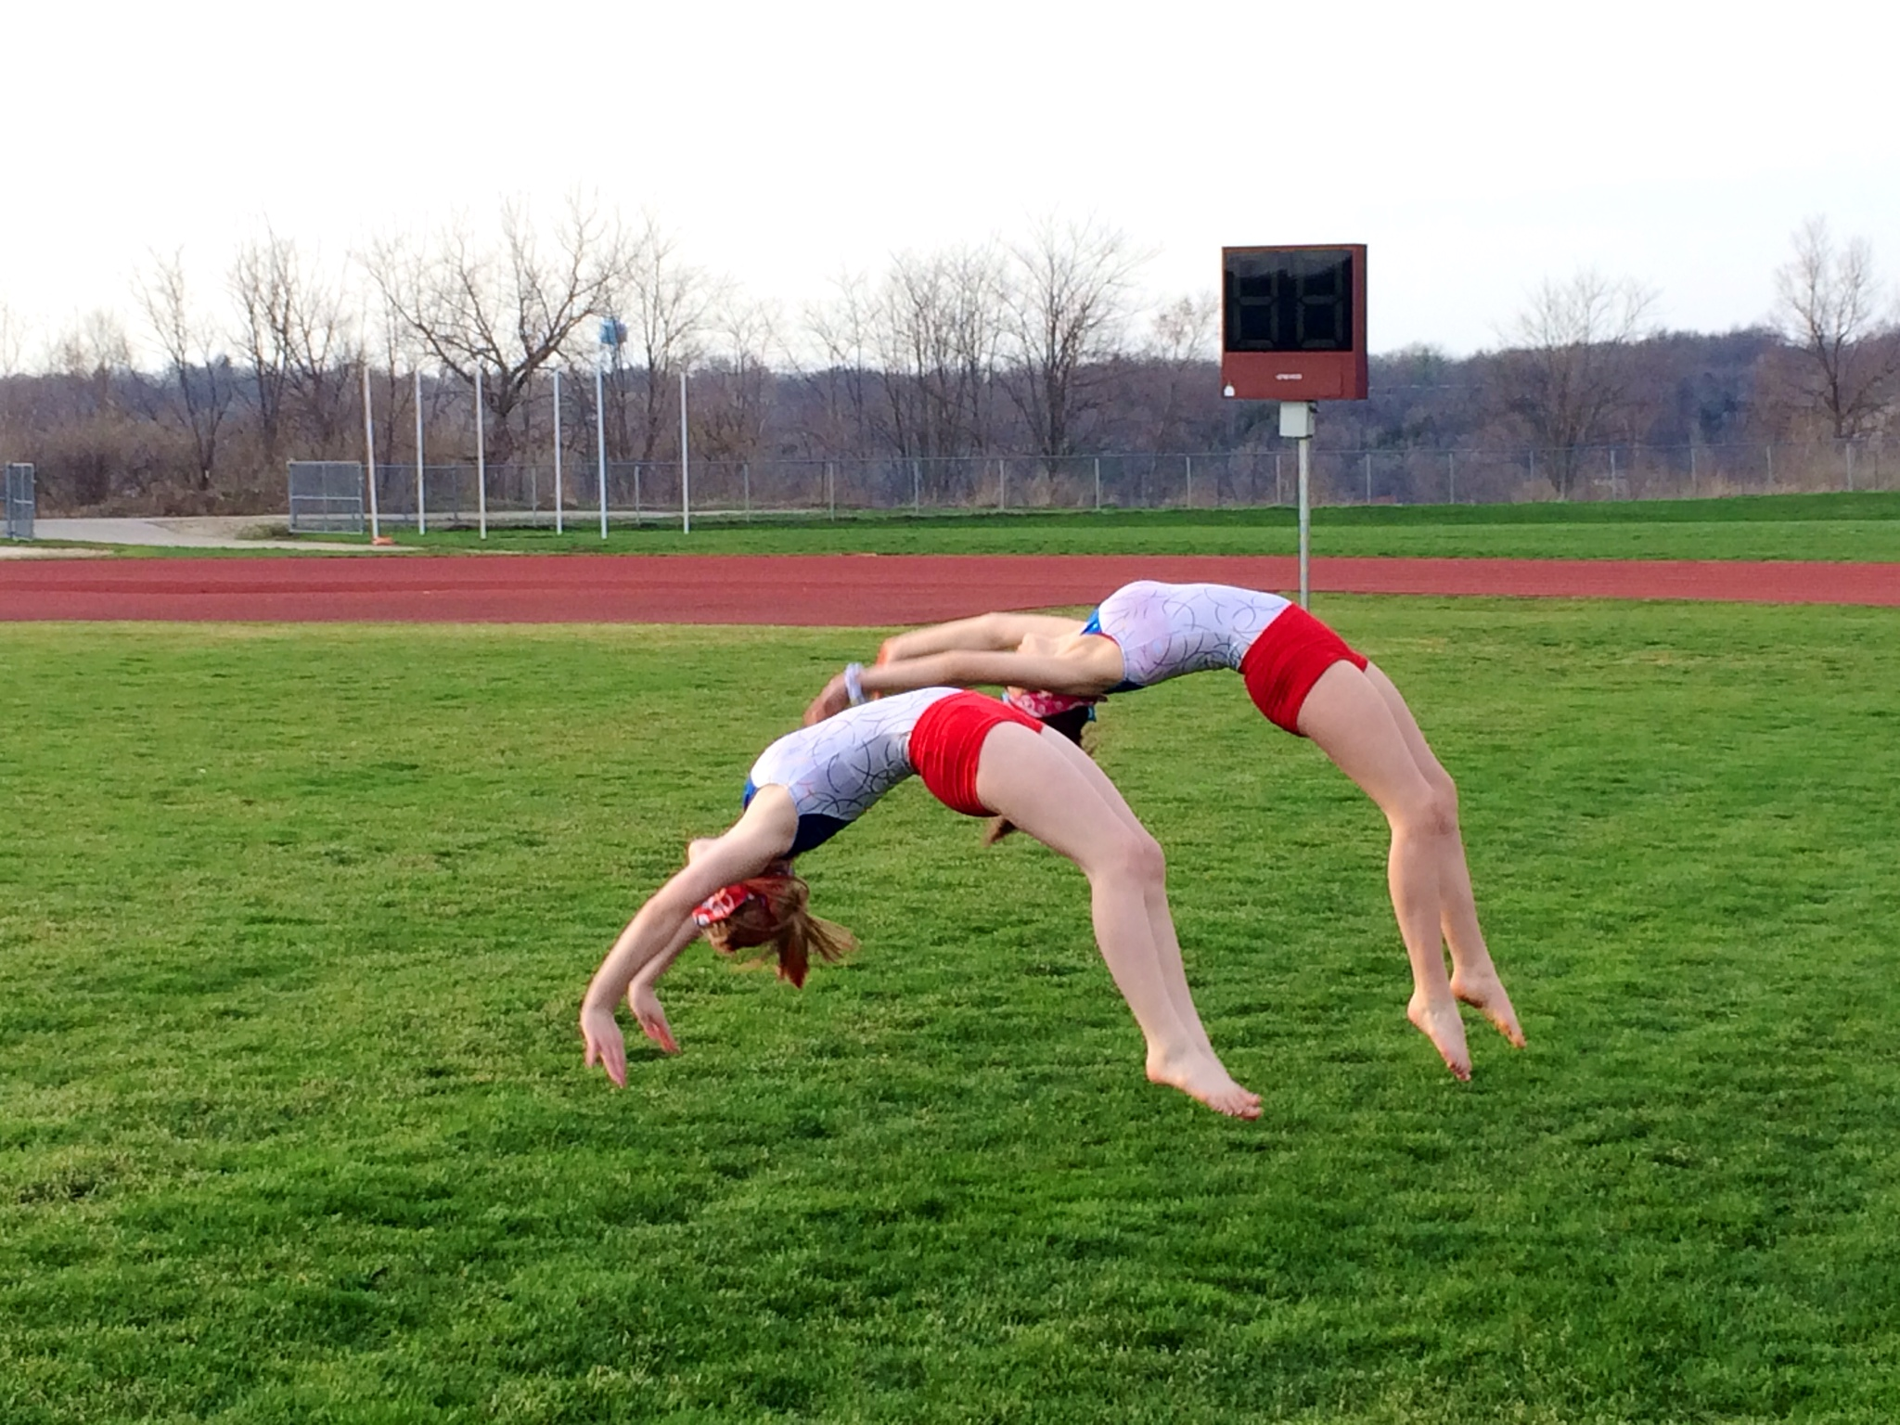

Though the instructors discourage it, children often want to practice their tumbling skills at home. Preforming tumbling skills in the grass, living room, or on a gym floor can be a lot of fun, but the key word is SAFELY! Beginner skills such as forward rolls, handstands, cartwheels, and round offs are good skills to be practiced at home. The more advanced skills such as back handsprings, back tucks, and twisting skills should not be attempted outside of the gymnastics facility. When a child comes to practice and says, “I got my back handspring!” a coach’s first thought is, “Where?!?” When a child teaches themselves a skill outside of the gym, it is not only dangerous, but it often leads to bad habits. Instead of learning the skill with the correct form, children typically develop their own technique when teaching themselves a skill. This only makes things harder on the athlete when the coach then tries to instill the correct technique. It is like relearning the skill all over again. Children can ALWAYS work on flexibility at home if he/she chooses.

### Why the phrase “I taught myself in the grass!”

### is terrifying to your coaches.

# Training at Home

July 2014

Top Star Newsletter

July Birthdays! If you see any of these athletes around the gym, be sure to wish them a happy birthday!

July 4th: Maddie Sikora

July 5th: Emma Franzen

July 8th: Ariana Veseli

July 12th: Jayla Ellerbe

July 15th: Colleen Hoerner & Olivia Johnson

July 16th: Jacob Fox & Katie Sikora

July 19th: Emily Grumish

July 21st: Morgan Springer

July 22nd: Loren Althoff & Olivia Smith

July 23rd: Alivia Learned & Lynnae Struck

July 25th: Anastasia Gordon

July 27th: Hailey Dukeman & Jenae Gustafson

July 30th: Coach Sydney

- Payton Turk: 24nd on advanced trampoline, 17th on intermediate floor, 19th on advanced double mini, 9th on advanced synchronized trampoline

USAG Nationals - July 15th-19th Louisville, KY

Our very own Delaney Walsh will be representing Region 4 on the Regional All Star Team for double mini at this competition! Delaney earned her spot on the team by receiving the highest overall score of level 10 double mini at Regionals in June! Way to go Dee!

## Upcoming Competitions

Top Star T&T – June 16th-21st – Louisville, KY

USTA Nationals

- Delaney Walsh: 2nd on advanced trampoline, 4th on elite trampoline, 3rd on advanced double mini, 5th on elite double mini, 2nd on advanced synchronized trampoline

## June Competition Results

###### We will be hosting another pizza party on Friday, July 25th! The party will run from 6:00 to 9:00 and will be $15 per child. Friends are welcome! Any friends who wish to attend will only need to pay the standard $15 pizza party rate and an event waiver will need to be filled out by a legal guardian. There is a sign-up sheet on the table by the office. Please write down any friend’s names as well. We look forward to seeing you and all your friends!

Anyone is welcome for only $15!

## July Pizza Party!

Competition Team Pictures

Top Star’s 2013-2014 competitive cheer and tumbling teams will be getting team pictures taken on Saturday, July 26th. Please arrive to the gym at 4:15pm with competition attire on and hair done appropriately. If you competed on both teams please bring both outfits! Individual photos will also be available once team pictures have been taken. Photos will be taken promptly so please be on time!

The first thing out of Sydney’s mouth when she was asked about her coaching job was, “Working at Top Star is the best part of my day!” Working with kids seems to be Sydney’s specialty! You can see the delight in her face while she is coaching and interacting with her athletes! Sydney started tumbling when she was 9 years old and competed for about 5 years. She has been coaching for Top Star for nearly a year now and has proven her dedication and appreciation for her job! Her favorite event to coach is double mini. Sydney loves to see her kids achieve and on double mini it is easy to set goals and accomplish them! Sydney will be a senior at Mahomet High School and is interested in psychology. She hopes to pursue her goal of becoming a family counselor. Sydney resides in Mahomet with her parents and brother.

Meet the Coach

Sydney Rinehart – T&T Coach

Summer sessions are only 3 weeks long! Because of this, fees will be different from the standard monthly pricing that everyone is used to! You will still pay by the hour and the new price list is up on the white board by the office. Please consult the board or ask a member of our staff to assist you when paying per session. Session 2 runs from Monday, July 7th through Thursday, July 24th. Please note that there is no break between sessions 2 and 3. Session 3 starts straightaway on Monday, July 28th.

We require proper gym attire to be worn during practices. Gymnastics leotards are ideal. We offer a rack of reasonably priced, consignment leotards in the gym. We know most of the girls prefer to wear shorts over their leotards, therefore we have practice appropriate shorts and leggings for sale in the office. Any tight fitting shorts will do. If your child does not have a leotard, please be sure to send them to practice in form fitting apparel. NO T-SHIRTS! Baggy clothes can be a hazard when coaches are spotting as the loose clothing can slip beneath our hands. Austin’s Sportswear in downtown Champaign has a sizeable selection of gymnastics leotards and shorts. Target also has a wonderful selection of children’s workout wear.

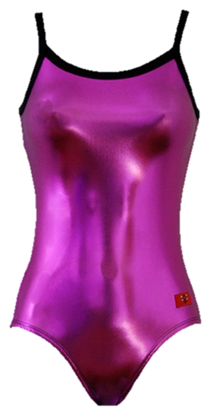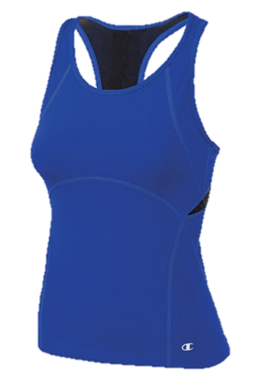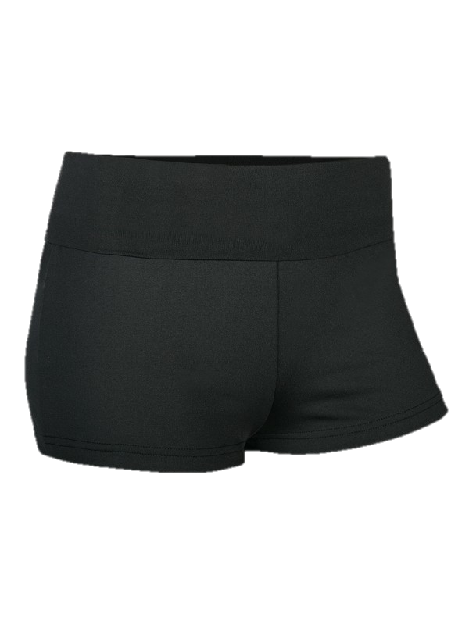

Reminder:

We are always interested in your opinions regarding our program and we are happy to hear your ideas. If any questions arise concerning our classes or policies, we encourage you to address them with our staff. You may speak to us directly or drop us a note in the gray payment box located by the office. We sincerely thank all of you for the continued support you show for our program!

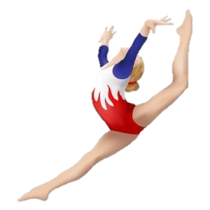

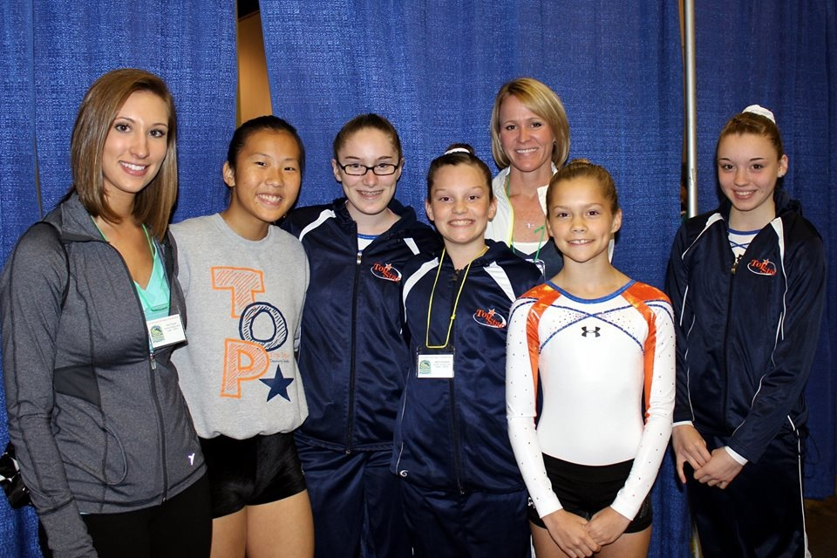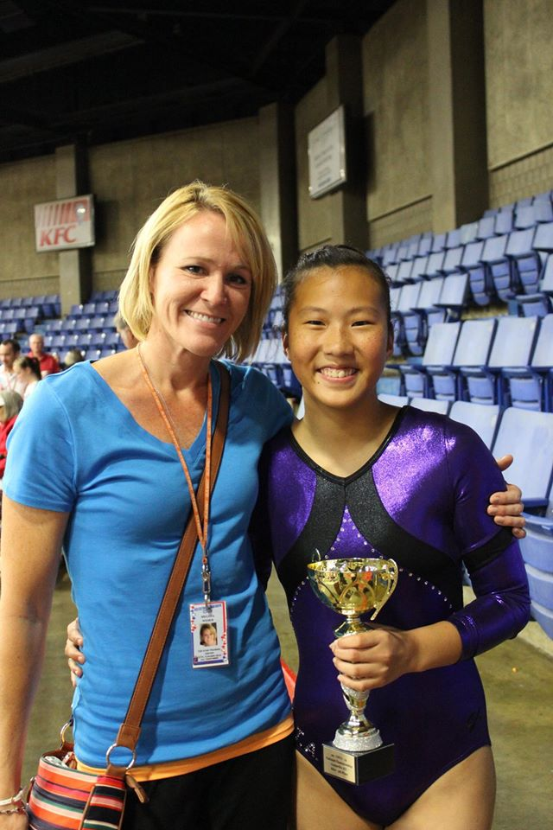

**Top Star Training Center**

1708 W. Hensley Rd

Champaign Illinois

217-378-5058

topstargym.net

topstargym@hotmail.com

#### We are so proud of our athletes, parents and coaches. Thank you for your dedication, loyalty, and support in helping us create a successful and confident family atmosphere.

Gymnastics was introduced in early Greek civilization as “gymnazein” which literally translates as “to exercise naked”. In Greek times, gymnastics included exercises such as running, jumping, throwing, and weight lifting. After the Romans conquered Greece, Rome developed the activities to help them physically prepare for war! In the 1800’s, after the development of a few present day events, Sweden adopted a more graceful form of the sport. European immigrants introduced gymnastics in America in the 1880’s. Men’s gymnastics was first scheduled in the Olympic Games in 1896. 40 years later, in 1936, women’s gymnastics was added to the Olympic line up. Today, there are six unique disciplines of gymnastics, these being: Men’s gymnastics, Women’s gymnastics, Rhythmic gymnastics, Acrobatic gymnastics, Trampoline and Tumbling, and Gymnastics for All.

## A Brief History Lesson