OCTOBERNews @ TOP STAR TRAINING CENTER

  - Issue Date

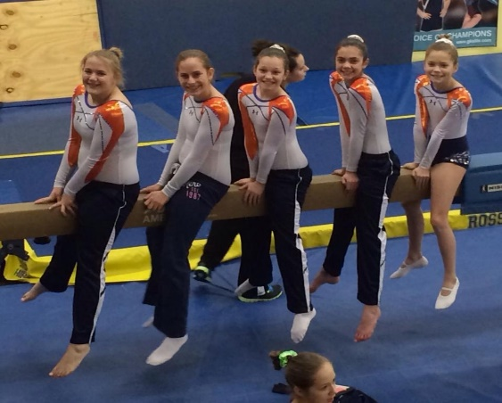

OOPS!!

We missed September!
by [Article Author]
We are so very sorry that we missed the September newsletter!! We have had several disappointed children in the gym because of this
We assure you, we are BACK ON TRACK and the newsletters will be monthly again!!

We are gearing up for another fun and exciting competition season!! We will begin our Trampoline and Tumbling season in early December and we will begin our 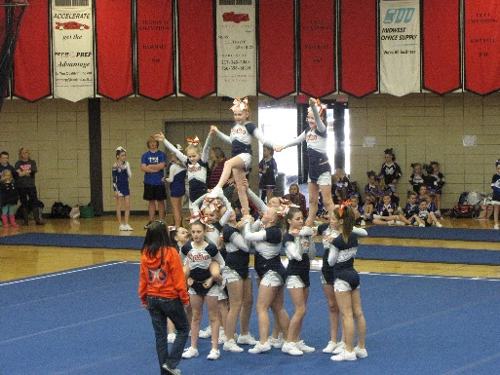Cheerleading season in late January! WE CAN’T WAIT!!

IN SEPTEMBER 2014 WE CELEBRATED OUR 9th YEAR IN BUSINESS!!!

SEPTEMBER BIRTHDAYS WE MISSED!!!
Sowwy guys

Lilly Daly 6th
Jenna Schaefer 7th
Olivia King 11th
Allison Schmitz 12th
Tucker Fox 16th
Betty Kennerly 16th
Meredith Hogue 18th
^{Chloe Harper 30th}

by

OCTOBER BIRTHDAYS
Raegan Paceley 7th
Zach Keitel 7th
Camryn Ward 9th
Lainey Jacobs 12th
Audrey McDaniel 14th
Madison Brocksmith 17th
Hannah Shields 20th
Ella Mohr 20th
Bailey Gordon 30th

How do YOU start your day ?

5 Things Successful People Do to Start Their Day*
Water, movement, and protein are the keys. When you wake up in the morning and finish brushing your teeth, drink 12-16 ounces of water. That will get you on your way to those eight glasses of water we all try to achieve. I know there is controversy with drinking the exact 64 ounces, but we all know hydration is important. Right then stretch overhead, your chest, do some squats while you brush your teeth, do some push-ups, yoga stretches, etc. Just move. The body will wake up and thank you for it. Be sure and get some protein in your first meal. It helps with repair, strength, and focus for the day. By starting like this you activate your body's autoresponders and get you off to a healthy, fit start. The next thing is to reflect on gratitude. Keep a journal and daily write down one thing you truly have to be thankful for. By starting your day feeling humbled and grateful, it puts you in a state of calm and peace. Any mind, body, spirit routine is perfect to start your day. You should do what so many CEOs and highly successful people do...write down just one thing that you will accomplish that day. You WILL NOT let the sun set until you have laser focused on this one item to do no matter what. So many of us get in the gym and we are pulled in so many directions. Don't start on anything else until you do the one most important thing to do. Pick the one thing that will propel your business forward the most. What is the one thing no one else in your organization can do that will make you more successful that day?
Start the day like the winners do!
*From Patti Komara’s October newsletter; successful gym and business owner since 1986

Light Bulb Moment
It's not the amount of things you get done on your to-do list, it's doing what's most important. Measure it by scale not by volume. At the end of the day wouldn’t it be nice to say, "I got a lot done today"? High performance is not multi-tasking every moment. Multi-tasking is out, important mono-tasking is in!

Don’t forget!!
With the snowy weather upon us, you must remember to check the website for closings and cancelations. We will post by 2:00 pm if we will close that day due to travel conditions. Remember, several of our coaches are driving a great distance and most of them are still teenagers. PLEASE be understanding if we need to close. I certainly don’t want to risk my coaches driving in or you all trying to get to the gym. We ALWAYS offer a make-up if we close due to weather.

FUN TRAMPOLINE FACTS

You know what a trampoline is, and you probably know that it was invented as a way for people to jump and enjoy acrobatics without the pain of hitting the ground (or the water, in the case of acrobatic diving) at the end of the jump. There are some other interesting facts about trampolines that you may not know, but that make for fascinating trivia.
The trampoline became famous after inventor George Nissen was photographed on a trampoline jumping with a kangaroo. While this photograph has been referred to as “chance,” and many people have referred to Nissen’s “luck” in having such a photo snapped, it was actually a planned publicity shot, which had exactly the effect Nissen hoped. Most people wonder how Nissen got the kangaroo to jump with him; he held its front paws so it could not kick him, and jumped, which caused both of them to bounce, of course. While the kangaroo has been referred to as “tame,” it actually was not.
The word trampoline comes from the Spanish “el trampoline,” for

diving board. Nissen was a diver and gymnast, and invented the trampoline to provide a safer way to do the acrobatics he loved in both sports.
Trampoline clubs flourish around the world, but Kent, England’s Gillingham Jumpers is the largest club in the world. The Jumpers generally have about 1,500 people jumping in the Jumpers Rebound Centre every week, more than any other known club.
But clubs are not the only arena for trampolines. In 2000, at the Sydney Olympics, Irina Karavaeva of Russia won the first gold medal in trampoline competition. George Nissen, then 86, attended the Games and saw Karavaeva win the gold.
Trampolines are becoming popular as extreme sports, as well. Not content simply to jump on a trampoline, many sports centers are now offering bungee trampolines, which involve a jumper strapping on a harness and bungee cord so they can jump higher and do more stunts on the trampoline.

YOU MAY NOT KNOW!

Competitive trampoline jumping is surprisingly popular, and has been around for some time, with the first World Champion, Judy Wills Cline, earning her first title in 1964. She eventually held ten world titles in trampoline, synchronized trampoline and tumbling. Dan Millman, who is now a well-know personal growth expert, was the first men’s World Champion in trampoline, and also won his first title in 1964.
But trampolines are not only an individual sport; in 1986 Cleveland State University’s Delta Epsilon fraternity fielded a six-man team that set the Guinness World Record for continuous bouncing on a trampoline, with 53 days of jumping between six people. President Reagan called the team to congratulate them. Other Guinness record categories for trampoline include a category for the longest slam-dunk by a basketball player on a trampoline.
Knowing interesting facts about trampolines may not make you a better jumper, but it certainly will make you a more interesting party guest, and the next time you’re jumping on your trampoline with friends, you might get a chance to share some of your unusual trampoline knowledge.

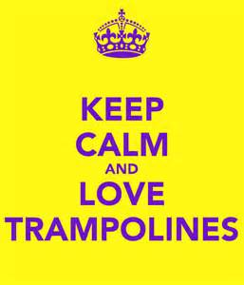Tiny

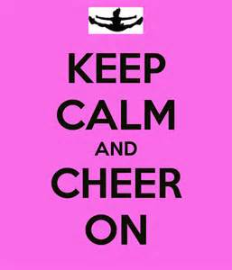
**********************
Cheerleading meets for our beginners on Wednesday nights 5:00-6:00 and for our more advanced cheerleaders 6:00-8:00 through October. November 2nd begins the Sunday practices! Come and check us out if you are interested in cheer!
*****************

Tiny Tots
Class times offered:
Monday 9:00-9:45am or 5:00-5:45pm
Tuesday 5:45-6:30
Wednesday 5:00-5:45
Thursday 6:00-6:45

Level 1-2
Class Times Offered:
Monday 5:00-6:00 or 6:00-7:00
Tuesday 4:45-5:45 or 6:30-7:30
Wednesday 5:00-6:00 or 6:30-7:30
Thursday 5:00-6:00 or 6:00-7:00
Saturday 9:00-10:00

Level 3
Class Times Offered:
Monday 6:00-7:30
Tuesday 4:30-6:00 or 6:30-8:00
Wednesday 6:00-7:30
Thursday 4:30-6:00 or 6:30-8:00
Saturday 10:00-11:30

Our goal at Top Star Training Center is to provide a safe and fun environment for your child. We believe in the importance of teaching solid basics in tumbling, trampoline and cheerleading from the beginning to produce the best athlete possible.

Tumbling Only
Class Times Offered:
ADVANCED (must have round-off back handspring on their own)
Monday 7:30-8:30
Thursday 7:30-8:30

INTERMEDIATE (working back handspring)
Tuesday 7:30-8:30
Wednesday 7:30-8:30

Trampoline & Tumbling Competition Team Classes
Monday 4:00-6:30 Trampoline/DM
Monday 6:00-8:30 Tumbling
Tuesday 4:00-6:30 Tumbling
Tuesday 6:00-8:30 Trampoline/DM
Wednesday 4:00-6:30 Tumbling
Wednesday 6:00-8:30 Trampoline/DM
Thursday 4:00-6:30 Trampoline/DM
Thursday 6:00-8:30 Tumbling
Saturday 9:00-11:30 LEVEL 7&up ONLY All 3 events

Top Star Training Center
1708 W. Hensley Rd
217-378-5058
topstargym.net
topstargym@hotmail.com

T & T Tentative Competition Schedule 2014-1015
USTA $15.00 Membership Fee
- December 6-7 Salem, IL
- January 31-February 1 HOME MEET MAHOMET, IL PLEASE MARK YOUR CALENDARS TO HELP!!!
- March 7-8 Chatham, IL
- March 21-22 Mattoon, IL
- April 18-19 Southern IL State Meet
- June 16-20 USTA Nationals Rapid City, SD
USAG $54.00 Membership Fee
- December 13 St. Louis, MO
- January 17 Washington, IN
- February 6-8 ELITE MOBILITY MEET Springfield, IL
- February 22 Crown Point, IN
- March 1 Dyer, IN TEAM CHALLENGE
- March 21 Terre Haute, IN
- March 22 Kewanee, IL
- March 29 HOME MEET MAHOMET, IL PLEASE MARK YOUR CALENDARS TO HELP!!!
- April 12 USAG IL STATE MEET Peoria, IL
- April 23-26 Elite Challenge TBA
- May 15-17 USAG Regionals for Region IV TBA
- June 23-26 USAG NATIONALS Levels 8-Elite TBA
Please pay your membership fees as soon as you can. If you are only doing one federation, please make it USAG. You are not required to compete both, but you may consider doing the USTA home meet on January 31-February 1.
Thanks!
Missy
********************************************************************************************************************************
2015 CHEER COMPETITION SCHEDULE

Date Host Team Location

January 25^{th(Tentative)} Cayla’s Power Tumbling & Cheer Effingham, IL St. Anthony’s High School

February 8th Prairieland Power Tumbling Arthur, IL Arthur High School

February 15th Top Star Mahomet, IL Mahomet-Seymour High School

March 1st Mattoon Academy Mattoon, IL Mattoon High School

March 28th Studio 50 Centralia, IL Centralia High School

April 25th All Star Gym DuQouin, IL DuQuoin High School

May 2nd Flipfastcis Benton, IL Benton High School

STATE AAU COMPETITION
Sunday, May 17th Cayla’s Power Tumbling & Cheer Effingham, IL St. Anthony’s High School

